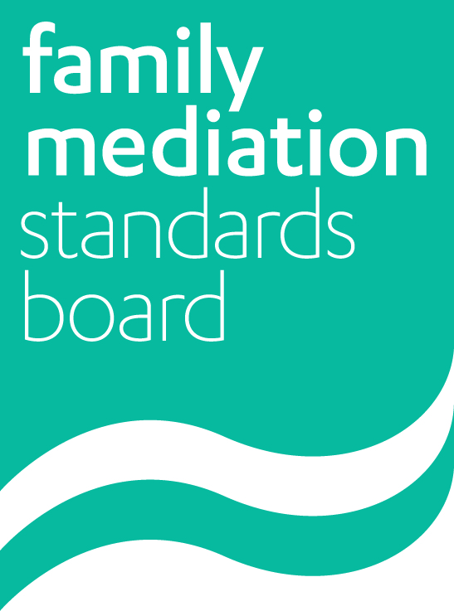
Family Mediation Standards Board

Application for approval of a Family Mediation Foundation Training Course

Section A

Provider details

1.1 Name of Organisation
1.2 Contact details
1.3 Legal status
1.4 Registered office if applicable
1.5 Details of person responsible for application
1.6 Details of person with authority to authorise the application, if different
1.7 Is the organisation part of a parent organisation, group or consortium? If so, please provide details of the parent organisation, consortium lead, and any other organisations involved in family mediation.

 |  | Criteria and guidance
1.8 Details of your financial resources to offer and run this training course effectively. |  | Are there any concerns that the organisation (a) will have difficulty organising the course and putting resources in place before fees are collected, or (b) is not sufficiently viable to ensure that courses are run to completion (including where participants need to retake elements of the course)?
1.9 Details of your administrative resources and operational capacity to offer and run this training course effectively. |  | Is the course adequately supported, in particular so that enquirers’ and participants’ queries are dealt with in a timely manner?
1.10 Names of all likely trainers (please append a short biography for each trainer – see checklist at the end). |  | Courses must have at least two trainers (2: 1.7).  At least 80% of the course must be taught by core trainers who are FMCA mediators and who either have a teaching or training qualification at England and Wales level 4 or above, or have previously acted as a core trainer on at least two comparable mediation courses (2: 1.7). Note that rather than a strict percentage, the important point is that all mediation content and practice must be taught/supervised by family mediators (specialist content could be taught by for instance a family lawyer or child psychologist).
1.11 Have your trainers agreed to provide the required training? If not, when do you expect them to have done so?
1.12 Details of previous family mediation courses offered by your organisation (or related courses if no previous family mediation training provided). Please append a selection of feedback on previous courses to include feedback where improvements to the course have been suggested (see the checklist at the end). |  | Providers should normally have experience of running comparable courses. If they do not, they may still be eligible provided that they are using sufficiently experienced trainers.

Section B

Course information

 |  | Criteria and guidance
1. Course entry requirements:  1.1 What are your entry requirements?  1.2 What evidence will you require from the participants to support this? |  | Do the entry requirements match with those stated in the standards manual (2: 1.2)?
2. Number of participants:  2.1 What is your minimum and maximum number of participants?  2.2. What is your proportion of trainers to participants? |  | Courses should normally have at least six participants (s2: 1.5, and must have at least one trainer to six participants for practical exercises (s2: 1.7).  If the number of participants is more than 15, check that the resources (accommodation as well as staff) can support an adequate level of practical training and individual feedback  .
3. Prior to a participant booking onto your course, please confirm that you provide the following information to each potential participant to enable them to make an informed judgment about undertaking the course:  3.1 Information about the course (for example on costs, dates, assessment process)  3.2 Information about the post training process to FMCA level  3.3 Information about all likely costs post training to FMCA level and beyond  3.4 Information about the level of PPC support needed (a) to achieve FMCA, and (b) on an ongoing basis  3.5 Detailed summary of learning objectives and course content | YES/NO  YES/NO  YES/NO  YES/NO  YES/NO | Participants must be provided with accurate information about the course itself, including whether the required post-training review is included in the cost of the course (see 2: 1.9).  The provider must also give a realistic estimate of the commitment and resources required to become a fully-qualified (FMCA) family mediator, and to continue practising, in order to enable participants to make an informed choice about training as a mediator.
3.6 Is your post training review (see 2: 1.9) included in your initial cost of training | YES/NO | It is not compulsory to include the review in the cost of the training, but the provider needs to make clear to potential participants that the review is required in order to continue towards FMCA status and has a cost implication.
4. Evaluation  4.1 How do you obtain feedback and evaluations from each participant?  4.2 How have you used feedback from previous courses? |  | The provider should have a system in place for obtaining feedback from participants and staff, and taking it into account both within the course if necessary and in the design of subsequent courses.
5. Course content  Please confirm that your course:  5.1 Reflects at least level 5 in the English or Welsh qualification frameworks  5.2 Provides training in terms of the principles of mediation to enable participants to:  - demonstrate a working knowledge of the theory underpinning key aspects of practice  5.3 Provides training in terms of the knowledge, techniques and skills of mediation to enable participants to:  - demonstrate a working knowledge of key aspects of practice  - undertake straightforward mediation without direct supervision  5.4 Provides training to enable participants to adhere to the FMC Code of Practice post training  5.5 Provides training to enable participants to undertake pre mediation assessment meetings and to undertake MAIMs once FMCA  5.6 Provides training in all aspects of children’s development attachment and well being post separation that are likely to be relevant in mediation  5.7 Provides training with regards to the principles of child inclusive mediation and the options available as outlined in the Voice of the Child Report 2015 with an understanding of the necessity for required additional training  5.8 Provides training in the principal financial issues that are likely to be relevant in mediation  5.9 Provides training in basic family law principles to enable clients to reach effective and workable solutions in the mediation process  5.10 Provides training to enable mediators to draft competent mediation outcome documentation  5.11 Provides a variety of teaching techniques that will provide participants with experiential practice and learning | YES/NO  YES/NO  YES/NO  YES/NO  YES/NO  YES/NO  YES/NO  YES/NO  YES/NO  YES/NO  YES/NO | See 2: 1.3.  See 2: 1.4. Are the course content and teaching methods adequate to prepare participants to understand and act according to the FMC professional competence standards (1: appendix 2), at an appropriate level for a new practitioner who may not be closely supervised?  See 2: 1.5.
5.12 If your course uses remote study time, how do you anticipate that this time will be spent, and what will it achieve? |  | See 2: 1.5. Ensure that independent study – as opposed to ‘structured on-line or distance learning…’ – is not included in the minimum 60 contact hours required for the course.
5.13 Please provide details of the duration of your course, including a breakdown between contact hours and remote study |  | See 2: 1.5.
5.14 How is your course divided (approximately) in terms of teaching methods and time allocated to each method?  5.15 Provide a (sample) timetable for your course (see the checklist at the end).  5.16 Please specify details of any distance learning to include amount of hours spent on:  - Using pre-prepared materials  - Investigation/personal study  - Tutor-led discussion  - Other discussion |  | See 2: 1.5. Ensure that independent study – as opposed to ‘structured on-line or distance learning…’ – is not included in the minimum 60 contact hours required for the course.
5.17 Explain how your course and teaching methods provide the participants with adequate opportunity to:  - learn the required principles and theory,  - reflect on and discuss principles and approaches and  - apply theory to practice and develop relevant skills |  | See 2: 1.5. There is no specific requirement for particular teaching methods beyond using a variety of methods that enable these requirements to be met.

Section C

Assessment of the participants

 |  | Criteria and guidance
1.1 What methods will you use for formal assessment of the participants during the course?  1.2 How will you ensure that participants do not pass the course until they are at an acceptable level to begin mediating without close supervision? |  | See 2: 1.6. Assessment methods must be:  - valid and sufficient for what they are assessing  - robust and consistent, i.e. do not result in participants being passed who are not ready to begin mediating with PPC support  - fair, i.e. do not create barriers that do not reflect the criteria being assessed.
1.3 How do you deal with concerns about the standards of individual participants? |  | The provider should provide early feedback and support to aid participants to reach the required standard.
1.4 If you are using more than one assessor, how will you ensure that standards are consistent between assessors? |  | Where more than one assessor is used, the provider needs to have in place an internal system of standard-setting and/or moderation.
1.5 How will you ensure that there is adequate external oversight of the assessment process and results? |  | Assessments must either be carried out or moderated by a person who has not been involved in training the person being assessed (see 2: 1.6).
1.6 Who do you (intend to) use as your external moderator or assessor?  1.7 Has this person agreed to acting in this role?  Please provide evidence of assessment material used to assess participants, both during and at the end of the course |  | The same criteria should apply as with trainers (2: 1.7), plus this should be a person with experience of assessment and/or moderation.

Where approval is provided, the Provider agrees to the following:

- To keep a record of participants for each course
- Provide and ensure collection of evaluation forms
- Provide evidence of analysis of evaluation forms as requested by FMSB from time to time
- Provide written confirmation of attendance and outcome to each participant
- Ensure proper attribution of training material and handouts and evidence that the permission has been obtained for their use where required
- Provide evidence of a complaints procedure in place to deal with matters arising at local and higher level

List of required supporting documentation:

- A short biography for each trainer (and assessor where different)
- The pre-course information provided to participants
- The course objectives and content, including those relating to skills development together with the criteria that will be used to assess participants’ achievement of the objectives
- A programme or timetable for a full course, including the teaching and learning methods to be used for each session, the number of trainers for each session, and the work expected to be undertaken between course days or blocks
- Feedback or evaluations on recent similar courses
- Assessment material used to assess participants, both during and at the end of the course.

Please note that reviewers can ask to inspect any course material at any time (with 10 days’ notice) and attend training courses.

Please email this form and your supporting documentation to info@familymediationcouncil.org.uk

