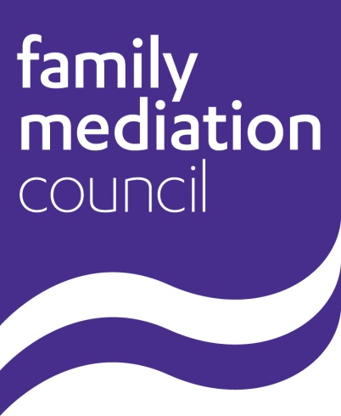

Annual Report
2016

Contents
1. Foreword
2. Who we are
3. Governance
4. Our achievements in 2016
5. Financial overview
6. Future work
Annex 1 – Accounts for year ending 31st December 2016
Annex 2 – FMSB Annual Report 2016

10th August 2017

1. Foreword
This is the second annual report of The Family Mediation Council (FMC), which was incorporated in 2015. It covers the period from 1st January to 31st December 2016.

2. Who we are
The FMC is dedicated to promoting best practice in family mediation. Our central aim is to ensure the public can confidently access family mediation services that offer high quality mediation provided by mediators who meet our standards.

The members of The Family Mediation Council (FMC) in 2016 were:

IDR Europe Limited (t/a ADR Group)
College of Mediators
The Law Society
Family Mediators Association (FMA)
National Family Mediation (NFM)
Resolution

Each member organisation appointed a director to the FMC Board of Directors and, in accordance with the Articles of Association, two other directors were co-opted.
The directors of The Family Mediation Council in 2016 were:

Hugh England, followed by John Taylor (Chair)
Karen Barham, appointed by Resolution
Cressida Burnet, followed by Richard Schiffer, appointed by IDR Europe Limited
Mark Paulson, appointed by The Law Society
Ewan Malcolm, appointed by College of Mediators
Jane Robey, appointed by NFM
Beverley Sayers, appointed by FMA
Aftab Pirbhai, from April 2016
Andrew Greensmith, until September 2016

The Company Secretary was Mr Paul Neale.

The FMC was supported in is work by an Executive Director and then an Executive Officer, a Communications Consultant and a Professional Standards Consultant, as well as an administrative office.

3. Governance
The FMC is a Company limited by guarantee.

Its Articles of Association can be found at: http://www.familymediationcouncil.org.uk/wp-content/uploads/2016/02/FMC-Articles-of-Association-1.pdf

The Company registration number is 9560220 and the registered office address is 2 Old College Court, 29 Priory St, Ware, Hertfordshire, SG12 0DE.

The board met approximately every two months in 2016 to consider matters of common concern and invited observers from the Ministry of Justice, the Family Justice Council, and the FMSB as appropriate.

4. Our achievements in 2016
In 2016, the FMC revised its Code of Practice for mediators, making changes regarding conflicts of interests, online video mediation, and child inclusive mediation. It also introduced Guidance for Online Video Mediation for the first time.

The FMC started important work to implement some of the recommendations of the Voice of the Child report, which was published in 2015, including asking a working group do child inclusive mediation trainers to make recommendations on the requirements for training and continuing professional development of mediators in child inclusive mediation.

The FMC also launched a consultation about family mediators drafting consent orders and agreed to draft a Code of Practice for PPCs.
The FMC provided a service online and by phone to help members of the public find family mediators throughout 2016, and started to publish a newsletter for mediators and other people who are interested in family mediation.

The FMC also supported to work of the FMSB, whose annual report is published at Annex 2.

5. Financial overview
The FMC’s Annual Accounts for 2016 were approved on 10 August 2017 and are attached at Annex 1.

The FMC continued to benefit from a grant from the MoJ, as it did in 2015. The total amount of the grant was £150,000 and the terms of the grant are set out in an agreement dated 23rd December 2014. This money has been spent on some of the cost of:
- the administrative function of the FMC, which in 2016 was outsourced to a company specializing in professional services administration, and the FMC’s running costs
- a Consultant Executive Director, two to three days per week (Sarah Lloyd), followed by an Executive Officer (Helen Anthony)
- a Communications Consultant, one day per week (Genevieve Fox)
- a Professional Standards Consultant (Stan Lester)
- ongoing FMSB board expenses; and
- accountancy costs.

In 2016, the FMC received registration fees from mediators. These fees were also used throughout the year to contribute to the running costs of the self-regulatory system, including administrative and executive support, and the work of external consultants as required.

The FMC continued to receive membership fees from its six member organisations, which paid for the cost of FMC board meetings including the travel expenses of its co-opted directors. FMC member organisations continued to bear the travel costs of their appointed directors’, as had happened prior to incorporation.
6. Future work
In 2017, the FMC will further strengthen its governance by co-opting another director to its board, and ensuring key policies such as those concerning data protection and complaints are fit for purpose.

The FMC will recruit new members to the FMSB, revisit the FMSB’s Terms of Reference, and continue to work with the FMSB to ensure the effective self-regulation of family mediators.

The recommendations of the FMC’s working groups on Child Inclusive Mediation and the PPC Code of Practice will be considered, as will responses to the FMC’s consultation about mediators drafting consent orders, and the FMC will start to carry out any work that arises as a result of these considerations.

The FMC will continue to work with stakeholders to further promote family mediation for the benefit of the public, including the MoJ and the Legal Aid Agency.

Annex 1
FMC Accounts for the Year Ending 31st December 2016

Annex 2
FMSB Annual Report 2016

