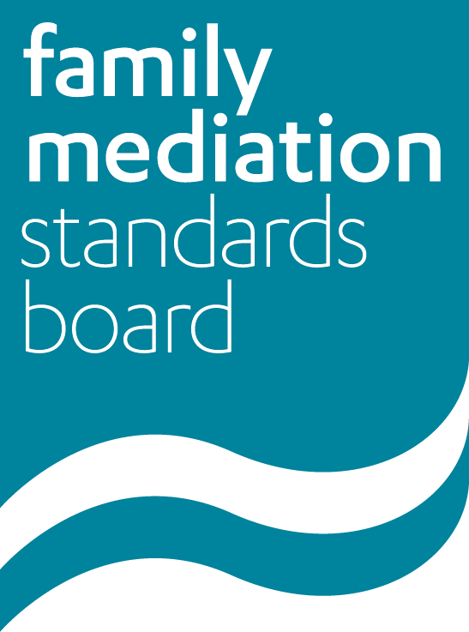**Child Inclusive Mediation (CIM) – Consultation on timetable**

**for implementing new training requirements**

The FMC has accepted [recommendations](https://www.familymediationcouncil.org.uk/2017/06/09/child-inclusive-mediation/) from its working group in relation to measures that should be taken to improve standards for child inclusive mediation. The FMSB is tasked with implementing

these measures, which include new training requirements.

The FMSB has considered the time that training providers will need to develop the recommended courses, and for the FMSB to approve these where relevant, as well as the practicalities and expense for mediators, and balanced these with the need to introduce these new requirements to raise the standards of child inclusive mediation without undue delay.

The FMSB has therefore proposed the following timetable for implementation (see below).

All training providers and mediators are welcome to comment on the proposed timetable for implementation, and specifically whether any of the requirements are thought to be either too onerous or too lenient. Please send any such comments to Helen Anthony via e-mail to [executive@familymediationcouncil.org.uk](mailto:executive@familymediationcouncil.org.uk) before 23rd October 2017.

**Timetable for mediators**

|  |  |  |
| --- | --- | --- |
|  |  | Timeframe |
| Arrangements for Trained but not FMC accredited | Must attend:  - CIM Awareness and Understanding Course (1 day) prior to the submission of their portfolio for accreditation.  All CIM training provides relevant CPD. | Applicable to those submitting portfolios on or after 1.9.19 |
| Arrangements for FMCA Mediator not CIM trained who wish to be CIM trained | Must attend:  - CIM Awareness and Understanding Course (1 day); and  - New FMC approved CIM Course (40 hours)  All CIM training provides relevant CPD. | By 1.1.20 or the mediator’s first post 2018 re-accreditation date, whichever is the latest. |
| Arrangements for FMCA Mediator not CIM trained who do not wish to be CIM trained | Must attend:  - CIM Awareness and Understanding Course (1 day)  All CIM training provides relevant CPD. | By 1.1.20 or the mediator’s first post 2018 re-accreditation date, whichever is the latest. |
| Arrangements for existing CIM mediators | Must attend  - CIM Update Course (1 day)  All CIM training provides relevant CPD. | By 1.1.20 or the mediator’s first post 2018 re-accreditation date, whichever is the latest. |
| Arrangements that mediators who are not CIM may make with other professionals to provide this service | The FMSB will draft requirements to agree with the FMC. Professionals who meet these requirements and comply with the rules may join an FMC Panel established for this purpose, whom mediators may refer to. | By 1.9.18 at the latest |
| CPD & Practice Requirements for CIM | Include CPD requirements for CIM in the Standards Framework.  Self certification on re-registration; details to be provided as part of re-accreditation process. | CPD Requirements from 1.1.19, to self-certify on re-registration by 2020 |
| CIM PPCs | PPCs who supervise mediators in relation to CIM work must also be CIM trained and comply with CPD requirements. | PPC requirements from 1.1.19, to self-certify on re-registration by 2020 |

**Timetable for training providers**

|  |  |  |
| --- | --- | --- |
|  |  | Timeframe |
| Child Inclusive Mediation Course  (40 hours of which 21 hours (3 days) must be at an attended course) | Mediators attending a child inclusive mediation training course on or after September 2018 must attend an FMC approved CIM course to be registered as able to carry out this work on the FMC register.  Course providers must tell the FMSB the names of those who pass this course and on what date. | Training courses to be submitted to FMSB for approval by June 2018  To apply to courses that start on or after 1 September 2018 |
| CIM Update Course (1 day) | Those already trained in DCC or CIM will need to attend a CIM update course, prior to their re accreditation, to ensure they are up to date with new requirements and competencies  This course must be run by an FMC approved CIM training provider.  Course providers must tell the FMSB the names of those who pass this course and on what date. | To be available for mediators to attend on or after 1 September 2018. |
| CIM Awareness and Understanding Course (1 day) | This course is needed for mediators who are not CIM trained. Course attendees may be working towards accreditation or accredited.  Attendance at this course is a pre-requisite for anybody wishing to undertake the CIM Course.  Course providers must tell the FMSB the names of those who pass this course and on what date.  This training course may be provided by either an approved foundation course provider or by an approved CIM course provider. | Available for approved foundation training providers to run from now (no certification required)  NB Providers will have to note FMC developments re arrangements for non-mediator child consultants as well as the new recommendations that are to be implemented with regards the new CIM course. |