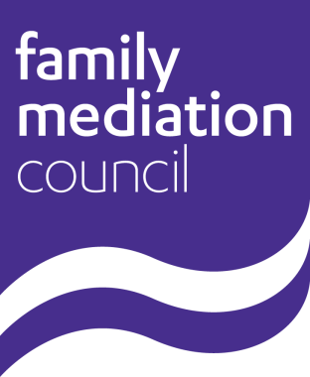
Equal Opportunities Monitoring Form

The Family Mediation Council is committed to promoting fairness and eliminating discrimination from recruitment and selection practices. We will ensure that no applicant for a post with us receives less favourable treatment either directly or indirectly, on the grounds of age, race, disability, gender, marital status, religion or faith or sexual orientation.

To monitor and audit the effective delivery of this commitment, the Family Mediation Council requests that all applicants provide information asked for in this monitoring form. This will only be used for this purpose, will form no part of the interview process and will be treated in strict confidence. It should be stressed that completing this form is entirely voluntary, and non-completion of this form will in no way adversely affect your application.

The form will be detached from your application and only used to help monitor the diversity of applications we receive. This will enable us to develop appropriate policies and procedures in respect of diversity and equal opportunities.

Post applied for:

Where did you learn of this post?:

1. Gender: Male Female

2. Date of birth:

3. Marital status: Married Single Divorced

Other (Please specify …………………………)

4. Nationality:

5. How would you describe your ethnic origin?

White |  |  |  | Black or black British
A | British |  |  | M | Caribbean
B | Irish |  |  | N | African
C | Any other white background |  |  | P | Any other black background
Mixed |  |  |  | Chinese
D | White and black Caribbean |  |  | R | Chinese
E | White and black African
F | White and Asian |  |  | Other ethnic group
G | Other mixed background |  |  | S | Please specify …………………………….
Asian or Asian British
H | Indian
J | Pakistani |  |  |  | Prefer not to say
K | Bangladeshi
L | Other Asian background
 | (please specify) …………………………………
6. Disability is defined by the Disability Discrimination Act as:

A physical or mental impairment, which has a substantial and long-term adverse effect on a person’s ability to carry out normal day-to-day activities. The disability could be physical, sensory or mental and must be expected to last at least 12 months.

Are you a disabled person as defined by the Disability Discrimination Act?
Yes No

7. How would you describe your religion or belief?

Christian Buddhist Hindu Jewish

Muslim Sikh None Prefer not to say

Other (please specify ……………………………………………)

8. What of the following describes your sexual orientation?

Bi-sexual Gay Heterosexual Lesbian

Other Prefer not to say

Thank you for completing this form. Please return it with your application.

