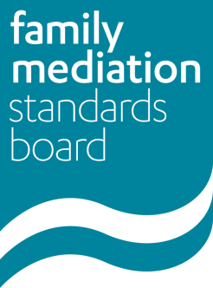
This form is for use by family mediators working towards accreditation who have not been practising, are not registered with the FMC for the current year, and are seeking confirmation from the FMSB of the further action that may be required prior to taking up practice again as a family mediator and being entered on to the register.

Name:
URN (if applicable):
E-mail address:
Phone number:

- Have you completed family mediation foundation training? If so, please provide the date of completion of your training and the name of the training provider.
- Approximately how much mediation, and how many pre-mediation assessment meetings, did you carry out before stopping practise as a family mediator?
- When did you stop practising as a family mediator?

- Please briefly state the reason for stopping practice (eg. family reasons, health reasons, pursuing other career path, travelling)

- Please confirm the details of your current or previous FMC member organisation(s)

- Have you carried out any relevant family mediation continuing professional development since stopping practice? If so, please provide details

- Please provide the name and URN of your PPC, details of how long they have been your PPC and the name of your PPC prior to you stopping practice, if different.

- If you have carried out any work (paid or voluntary), been on any courses or had any training since you stopped practice, and think the skills/experience may be relevant to your work as a family mediator, please provide details of this.

- Have you ever had membership of an FMC Member Organisation revoked?

- Are there any past, current or known future reasons why you should not practise as a family mediator?

Please attach an action plan, endorsed by your PPC, setting out your proposed action with regards supervision, continuing professional development and mediation practice, that will bring you to the required level to start working towards accreditation again.

Signed:
Date:

Please send this completed form and your action plan to: fmsb@familymediationcouncil.org.uk with ‘Mediator working towards accreditation – Return to practice’ in the subject line.

The FMSB will then consider your application and aims to respond within 10 weeks. It will either endorse your action plan or propose further steps that you will need to take to recommence practice as a family mediator.

