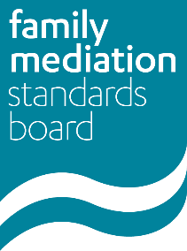
Complaint Form
If you have a complaint about an FMC Registered Mediator breaching the FMC’s Codes of Practice or professional standards and have completed the Mediator’s own complaints process within the last 3 months, please complete this form and send with any supporting documents to complaints@familymediationcouncil.org.uk

Your name

Your e-mail address

Your telephone number

Name of Mediator

URN of Mediator
Each FMC Registered Mediator has a unique reference number. Please enter this here if you can as it helps identify the person you are making the complaint about. You can look up each mediator’s URN on the Family Mediation Council website here.

Your status
You can make a complaint if you are
- A client or former client of the mediator
- A prospective client of the mediator
- A person who has been invited to take part in the mediation process
Please tell us which applies to you.
Have you completed the mediator’s own complaints process?

When did the mediator’s own complaints process conclude?

Please set out below the details of your complaint.
If you have printed this form out and are completing it by hand, you can include details of your complaint on a separate sheet of paper.
You must enclose any documents you would like the FMSB to take in to account when considering your complaint. Please list below any documents you are enclosing.

Declaration

I understand that the information in my complaint, including any documents supplied, will be disclosed to the Mediator complained about.

Name: Date:

Once completed, please send this form and any supporting documents to complaints@familymediationcouncil.org.uk
Complaints will be acknowledged within 5 working days and considered in accordance with the FMSB’s complaints process.
All information is held in accordance with the FMC’s Privacy Notice.

