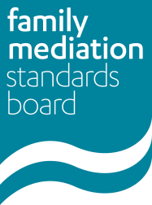
Logging PPC extension of time to submit portfolio (Category A)
Use this form to notify the FMSB that your PPC has given you an extension of time to submit your portfolio due to circumstances which have meant you have had to take time off work since completing your training (due to maternity, paternity, illness, bereavement or similar).
Please read the Policy and Guidance carefully before completing this form, asking your PPC to sign it, and returning it to fmsb@familymediationcouncil.org.uk before your deadline to submit your portfolio.
To be completed by the mediator
Name

URN

Deadline to submit portfolio
I will not be able to submit my portfolio for assessment by this date due to time taken off work due to the circumstances set out in the Standards/guidance and my PPC has granted an extension on this basis.
Brief reasons for extension (eg maternity, paternity, illness, bereavement)

Length of time not mediating
Length of extension
(this can be no more than the length of time taken off work, plus four months for the mediators to re-establish themselves)
New deadline for submitting portfolio
Signed
Date
To be completed by the mediator’s PPC
Name
URN
I am this mediator’s PPC. I have given this mediator an extension above in line with the PPC extension policy and confirm the accuracy of the information set out in this request to the best of my knowledge and belief.

Signed
Date

For FMSB use only:
Extension granted: Yes/No
New portfolio deadline:
Reviewer: Date:

